

**SIX WEEK SUMMER TRAINING REPORT**

on

***DATA SCIENCE & MACHINE LEARNING***

Submitted by

**RANJITH SK**

Reg. No: **12007594**

**B.Tech (Computer Science Engineering) Hons**

Under the Guidance of

**PRANAY SHARMA**

(Coordinator for the project at IBM(All Soft Solutions))

**School of Computer Science & Engineering**

**Lovely Professional University, Phagwara**

(June - July, 2022)

**DECLARATION**

I hereby declare that I have completed my six weeks summer training at  **All Soft Solutions(IBM), Punjab** through online classesfrom **June 6** to **July 8** under the guidance of **Pranay Sharma.** I declare that I have worked with full dedication during this training and my learning outcomes fulfil the requirements of training for the award of degree of **B.Tech (Hons)**, Lovely Professional University, Phagwara.

**RANJITH SK**

Reg.No: **12007594**

Date:14/07/2022

Expert from IBM(Teacher): **Pranay Sharma**

**ACKNOWLEDGEMENT**

The success and final outcome of this project required a lot of guidance and assistance from many people and I am extremely fortunate to have got this along the completion of my project work. Whatever I have done is only due to such guidance and assistance and I would not forget to thank them.

I would like to express my respect and gratitude to the teachers of Lovely Professional University and the coordinator for providing this opportunity to do this training program and project regarding **data science & machine learning.**

I would also like to extend my gratitude to **Pranay Sharma**(Teacher from IBM/All Soft Solutions) who helped us by giving guidance and support all through the program and also in completing the project.

**SUMMER TRAINING CERTIFICATE**

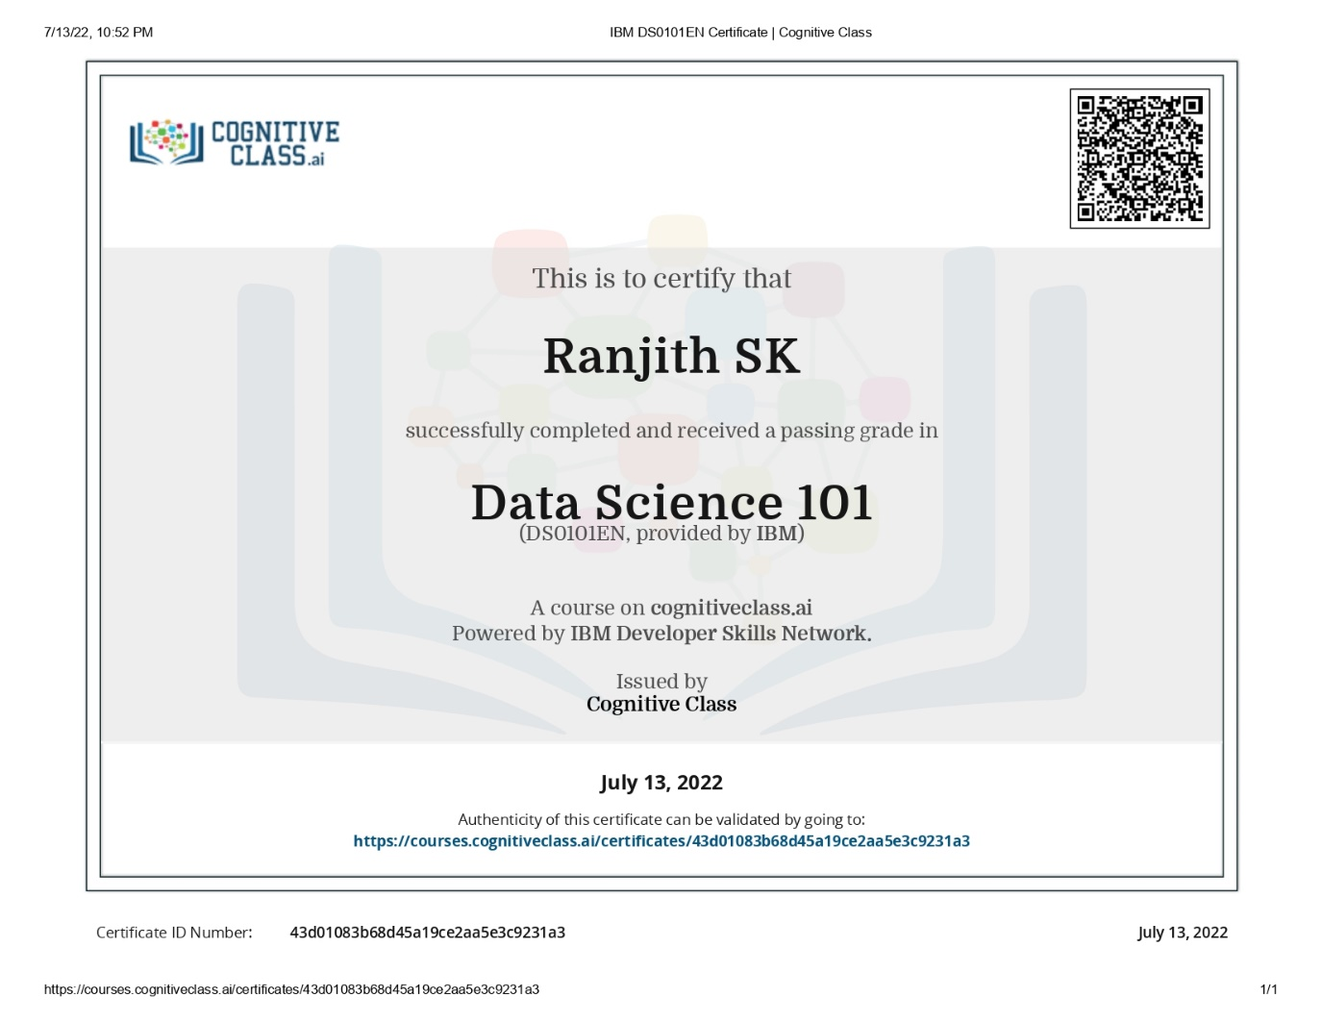

**TABLE OF CONTENTS**

1. Introduction
2. Technology Learnt
3. Reason for choosing this Technology
4. Profile of the Problem
5. Existing System
6. Problem Analysis
7. Software Requirement Analysis
8. Design
9. Implementation
10. Learning Outcome from training/technology learnt
11. Gantt Chart
12. Profile Legacy
13. Bibliography

**INTRODUCTION**